What is an Adverb?

Adverbs are words that are used in sentences to describe or change the meaning of a Verb or Adjective or even another Adverb. They add a description to the sentence to make it more detailed and interesting. For example:

* *He walked****slowly****across the square.*

Here, one can see that the Adverb ‘slowly’ is describing the Verb ‘walk’ by telling that the person was walking slowly.

Types of Adverbs

Adverbs are used in sentences to answer many questions about the [Verbs](https://7esl.com/common-verbs/)/Adjectives/Adverbs themselves. The different types of Adverbs are as following:

Adverb of Time

What is an adverb of time? Look at examples below:

E.g.: *The results were announced****yesterday****.*

Here the Adverb is **yesterday** which is answering the question: **When**were the results announced? ‘Announced’ is the verb in this sentence.

E.g.: *She will visit the hospital****tomorrow****.*

Here the Verb is ‘visit’ and the Adverb is **tomorrow**as the question being asked is: **When**will she visit the hospital?

Other examples of Adverbs of Time are – Once, Never, Tomorrow, Daily, etc.

Adverb of Place

What is an adverb of place? Look at examples below:

E.g.: *They will meet you****there****.*

The Adverb here is **there**that is specifying a place for the Verb meet and the question being answered is: **Where** will they meet you?

E.g.: *In spring, flowers bloom****everywhere****.*

Here the Verb is bloom and the Adverb is **everywhere,** answering the question: **Where**do the flowers bloom in spring?

Other examples of Adverbs of Place are – Anywhere, Somewhere, Near, Far, etc.

Adverb of Manner

What is an [adverb of manner](https://eslgrammar.org/adverbs-of-manner/)? Look at examples below:

E.g.: *He****quietly****slipped away.*

The Adverb here is **quietly**which is telling the way or manner in which the action was carried out and the Verb is slipped which is telling: **How**did he slip away.

E.g.: *She works****fast****.*

The Verb here is work and the Adverb is **fast**and the question being asked is: **How**does she work?

These Adverbs tell about the manner of the action being done, whether it is done happily or haltingly etc. Other examples of Adverbs of Manner are – Honestly, Joyfully, Cunningly, etc.

*Types of Adverbs – Adverbs of Manner | Image*

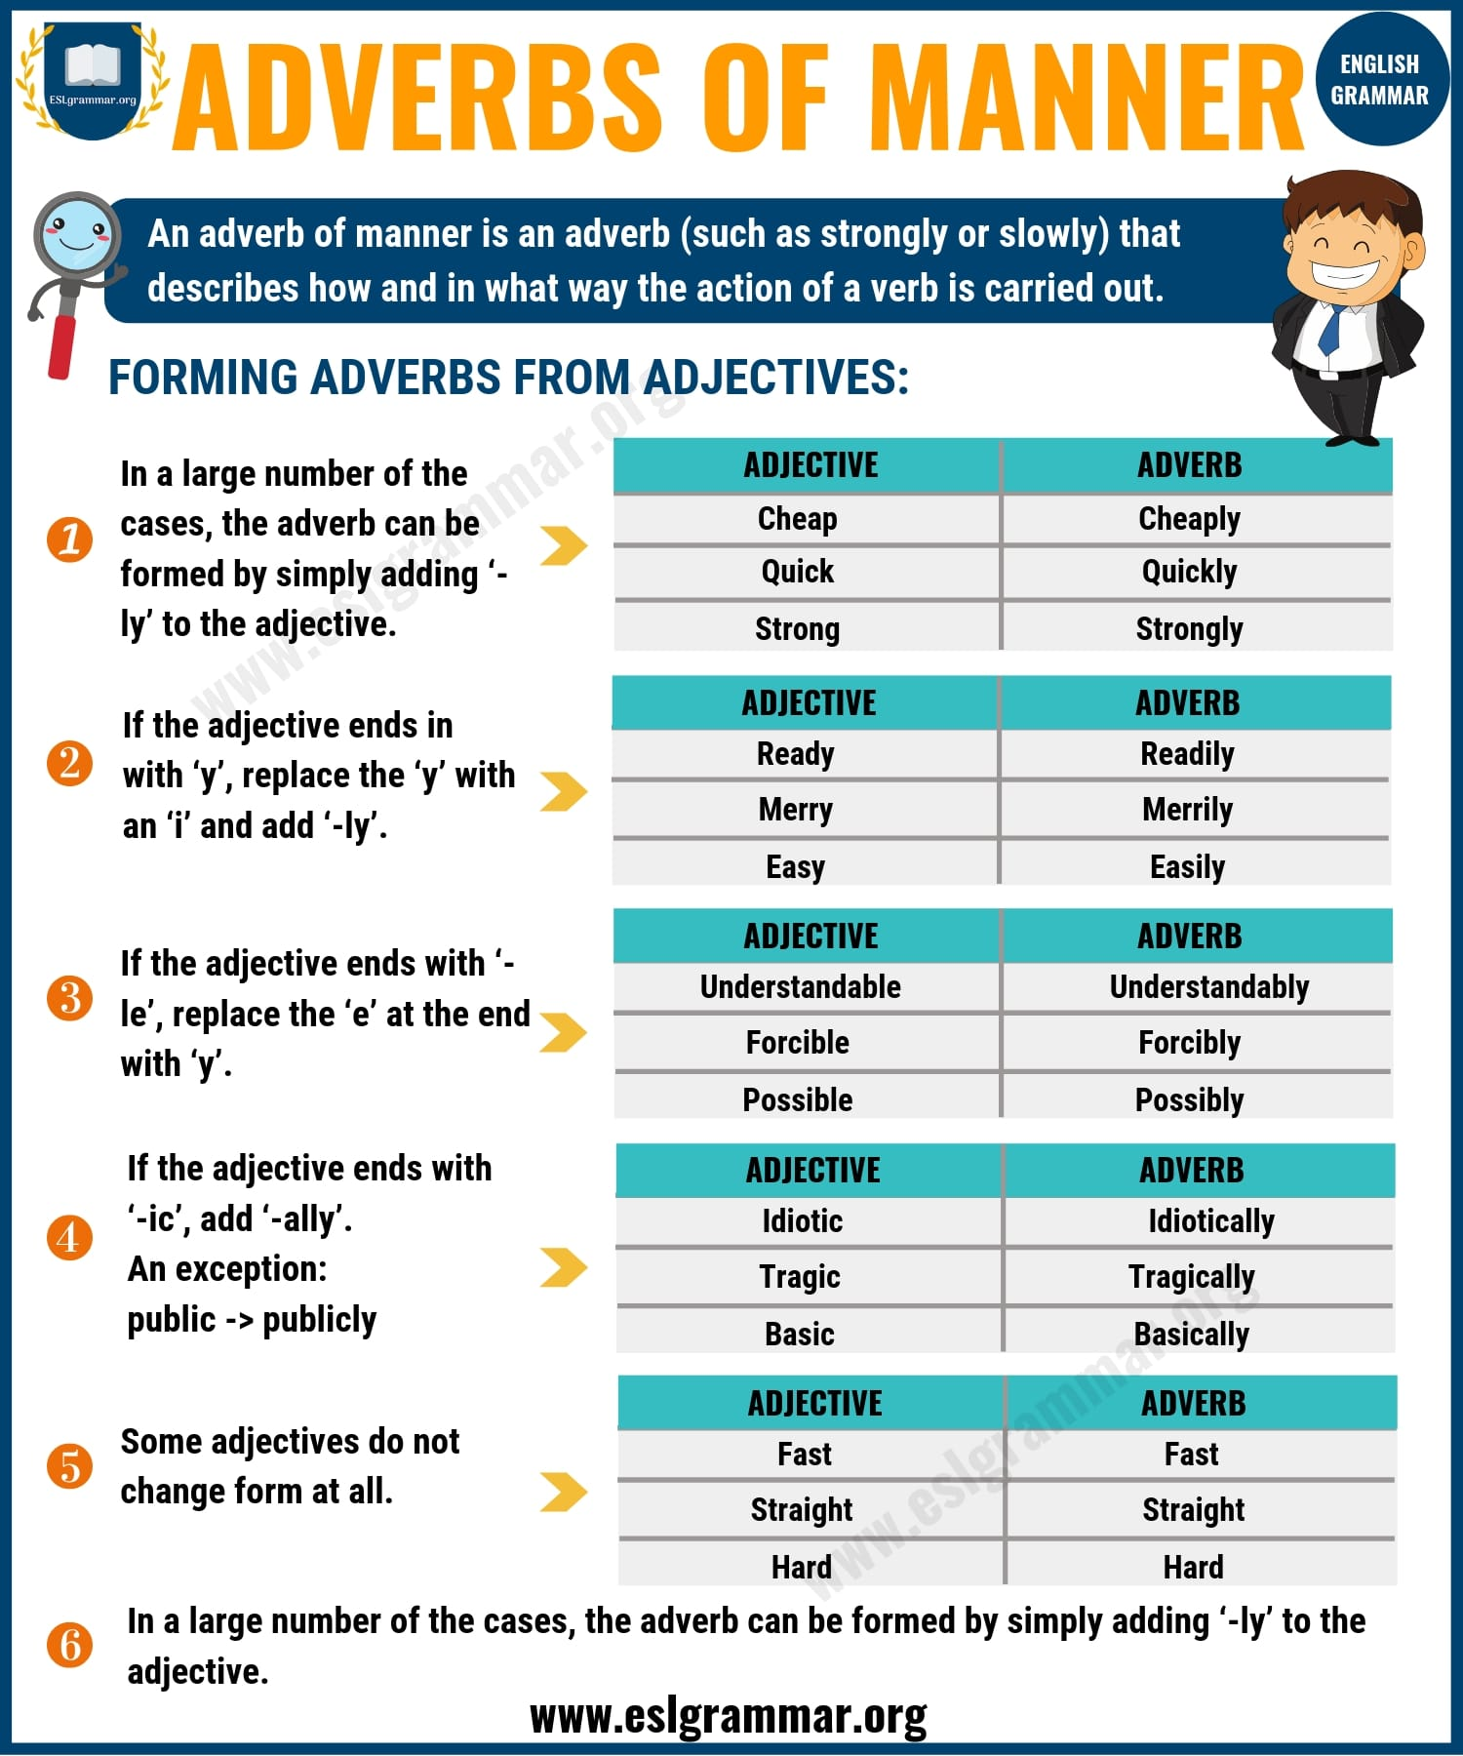Pin

Adverb of Frequency

What are [adverbs of frequency](https://eslgrammar.org/adverbs-of-frequency/)? Let take a look at those examples below:

E.g.: *He likes to watch TV****every day.***

Here, the Adverb is **every day** and it is telling about the amount of time spent in doing the Verb, which is watch. The question in this sentence is: **How often**does he watch TV?

E.g.: *They meet****every week****.*

The Adverb here is **every week**and it is telling the frequency and the Verb is meet. The sentence is telling us: **How often**do they meet?

These Adverbs are used to show the duration or timing of the action that is happening/had happened/will happen. They also tell us how often and how long these actions would be.

Other examples of Adverbs of Frequency are – Frequently, Often, Yearly, Briefly, etc.

Adverbs of Frequency | Image

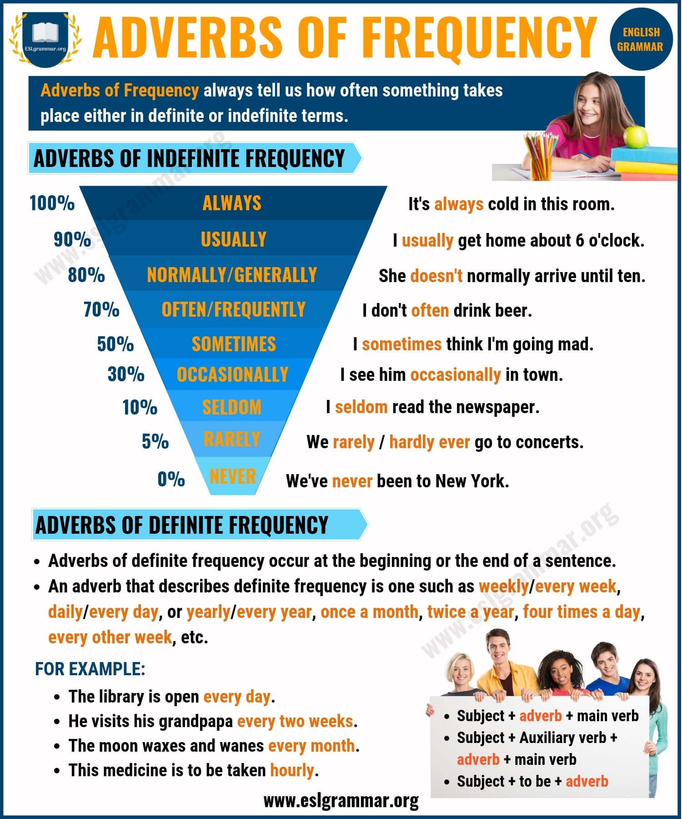Pin

### Adverbs of Degree

E.g.: She ***almost***finished the work.

The Verb here is finished and the Adverb is **almost**which is telling us about the amount of the work finished. The question being asked is: **How much** of the work did she finish?

E.g.: They were ***completely*** surprised by the windfall.

The adverb here is **completely** which is showing the degree to which ‘they’ were surprised which is the Verb. The question being asked here is:**How much**were they surprised?

The Adverbs of Degree are used to show to what extent or how much has an action been done or will be done.

Other examples of these Adverbs are – Fully, Partially, Altogether, etc.

Adverbs of Confirmation and Negation

E.g.: *They will****certainly****like this vase.*

The Adverb here is **certainly** which is reinforcing the Verb like in answer to the question: **Will**they like this vase?

E.g.: *He****never****leaves his house.*

The Adverb **never** is negating the Verb leave. It is answering the question in denial: **Does**he ever leave his house?

These Adverbs either confirm or deny the action of the Verb. They are also used to reinforce the action that is described by the Verb.

Other examples of Adverbs of Confirmation are – Definitely, Absolutely, Surely, etc. Examples for Adverbs of Denial or Negation are – No, Don’t, Can’t, etc.

Adverbs of Comment

These Adverbs are used to make a comment on the entire sentence. They give a look at the speaker’s viewpoint or opinion about the sentence. These Adverbs don’t just change or describe the Verb; they influence the whole sentence.

They found his secret easily.

+

Unfortunately

**Unfortunately, they found his secret easily.**

Here, we see that adding the Adverb, unfortunately, has changed the entire tone of the sentence. Earlier, it was a passive tone, now it has a negative or disappointed tone.

Other examples of Adverbs of Comment are:

* ***Luckily****, the dog did not bite the children.*
* ***Happily****, the power returned before the big match.*
* *Did he****honestly****expect me to lie for him?* (Adverb adds comment on the anger of the speaker.)
* *And they would win the world cup,****obviously****.* (Can be said in a sarcastic as well as positive manner)

Adverbs of Conjunction

What are adverbs of conjunction?

These Adverbs are used to connect ideas or clauses, they are used to show consequence or effect or the relation between the two clauses. To use these Adverbs to conjugate two clauses you need to use a semicolon (;) to connect them.

Clause 1: *He was going for an important interview.*

Clause 2: *He made sure he reached on time.*

He was going for an important interview**; accordingly**, he made sure he reached on time.

Here, we see how the Adverb ‘**accordingly**’ is joining the two clauses and showing the relation between them with the use of a semicolon (**;**). Accordingly means- therefore or that is why.

A few other Adverbs of Conjunction are:

* **However** – Yet, on the other hand, in spite of
* **Consequently** – As a result, resulting in
* **Moreover** – Beside, in addition
* **Conversely** – Opposite of, contrary to

Position of Adverbs

What is the [correct place to put an adverb](https://eslgrammar.org/position-of-adverbs/) in English sentences?

Adverbs can be used in diverse ways, which means that they are very flexible in sentences; they can be moved around quite a bit without causing any grammatical irregularities.

**Adverbs are used to begin sentences/clauses**

* *I did not care for her tone.****However****, I let it go.*
* ***Tomorrow****I am leaving for Calcutta.*

**Adverbs are used in the middle of sentences**

* *You are****always****late.*
* *I will****probably****be absent at the party.*

**Adverbs  are used to at the end of sentences**

* *He wrote the answers****correctly****.*
* *His stammer caused him to speak****haltingly****.*
* …

*Position of Adverbs | Image*

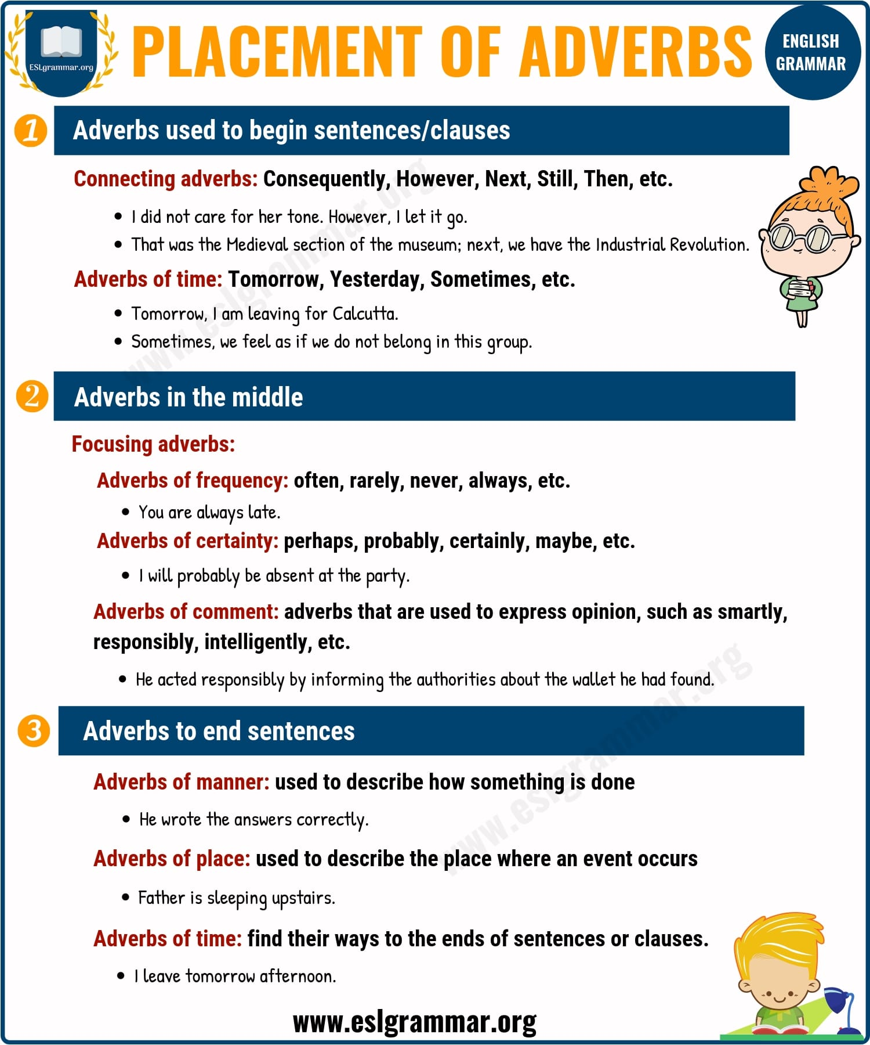Pin

Types of Adverbs | Infographic

*8 Common Types of Adverbs in English | Image*

